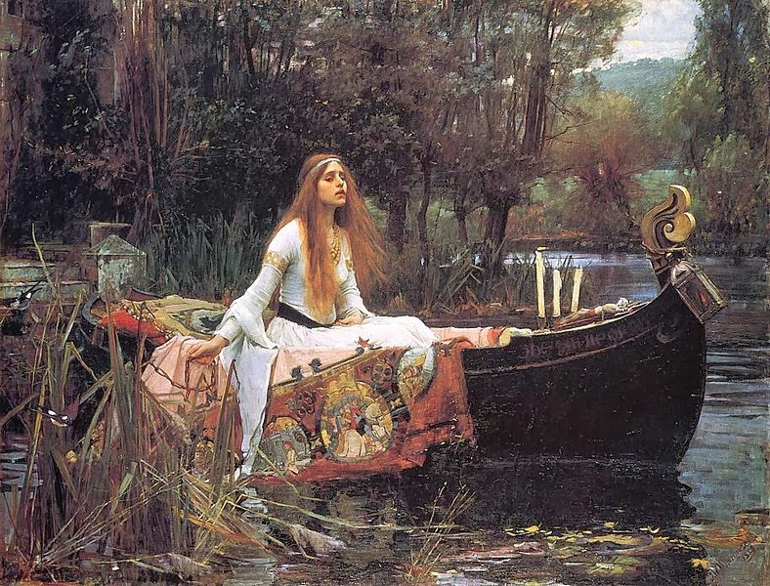

Alfred Tennyson. The Lady of Shalott
On either side the river lie
Long fields of barley and of rye,
That clothe the wold and meet the sky;
And through the field the road run by
To many-tower'd Camelot;
And up and down the people go,
Gazing where the lilies blow
Round an island there below,
The island of Shalott.
Willows whiten, aspens quiver,
Little breezes dusk and shiver
Through the wave that runs for ever
By the island in the river
Flowing down to Camelot.
Four grey walls, and four grey towers,
Overlook a space of flowers,
And the silent isle imbowers
The Lady of Shalott.
By the margin, willow veil'd,
Slide the heavy barges trail'd
By slow horses; and unhail'd
The shallop flitteth silken-sail'd
Skimming down to Camelot:
But who hath seen her wave her hand?
Or at the casement seen her stand?
Or is she known in all the land,
The Lady of Shalott?
Only reapers, reaping early,
In among the bearded barley
Hear a song that echoes cheerly
From the river winding clearly;
Down to tower'd Camelot;
And by the moon the reaper weary,
Piling sheaves in uplands airy,
Listening, whispers, " 'Tis the fairy
The Lady of Shalott."
There she weaves by night and day
A magic web with colours gay.
She has heard a whisper say,
A curse is on her if she stay
To look down to Camelot.
She knows not what the curse may be,
And so she weaveth steadily,
And little other care hath she,
The Lady of Shalott.
And moving through a mirror clear
That hangs before her all the year,
Shadows of the world appear.
There she sees the highway near
Winding down to Camelot;
There the river eddy whirls,
And there the surly village churls,
And the red cloaks of market girls
Pass onward from Shalott.
Sometimes a troop of damsels glad,
An abbot on an ambling pad,
Sometimes a curly shepherd lad,
Or long-hair'd page in crimson clad
Goes by to tower'd Camelot;
And sometimes through the mirror blue
The knights come riding two and two.
She hath no loyal Knight and true,
The Lady of Shalott.
But in her web she still delights
To weave the mirror's magic sights,
For often through the silent nights
A funeral, with plumes and lights
And music, went to Camelot;
Or when the Moon was overhead,
Came two young lovers lately wed.
"I am half sick of shadows," said
The Lady of Shalott.
A bow-shot from her bower-eaves,
He rode between the barley sheaves,
The sun came dazzling thro' the leaves,
And flamed upon the brazen greaves
Of bold Sir Lancelot.
A red-cross knight for ever kneel'd
To a lady in his shield,
That sparkled on the yellow field,
Beside remote Shalott.
The gemmy bridle glitter'd free,
Like to some branch of stars we see
Hung in the golden Galaxy.
The bridle bells rang merrily
As he rode down to Camelot:
And from his blazon'd baldric slung
A mighty silver bugle hung,
And as he rode his armor rung
Beside remote Shalott.
All in the blue unclouded weather
Thick-jewell'd shone the saddle-leather,
The helmet and the helmet-feather
Burn'd like one burning flame together,
As he rode down to Camelot.
As often thro' the purple night,
Below the starry clusters bright,
Some bearded meteor, burning bright,
Moves over still Shalott.
His broad clear brow in sunlight glow'd;
On burnish'd hooves his war-horse trode;
From underneath his helmet flow'd
His coal-black curls as on he rode,
As he rode down to Camelot.
From the bank and from the river
He flashed into the crystal mirror,
"Tirra lirra," by the river
Sang Sir Lancelot.
She left the web, she left the loom,
She made three paces through the room,
She saw the water-lily bloom,
She saw the helmet and the plume,
She look'd down to Camelot.
Out flew the web and floated wide;
The mirror crack'd from side to side;
"The curse is come upon me," cried
The Lady of Shalott.
In the stormy east-wind straining,
The pale yellow woods were waning,
The broad stream in his banks complaining.
Heavily the low sky raining
Over tower'd Camelot;
Down she came and found a boat
Beneath a willow left afloat,
And around about the prow she wrote
The Lady of Shalott.
And down the river's dim expanse
Like some bold seer in a trance,
Seeing all his own mischance --
With a glassy countenance
Did she look to Camelot.
And at the closing of the day
She loosed the chain, and down she lay;
The broad stream bore her far away,
The Lady of Shalott.
Lying, robed in snowy white
That loosely flew to left and right --
The leaves upon her falling light --
Thro' the noises of the night,
She floated down to Camelot:
And as the boat-head wound along
The willowy hills and fields among,
They heard her singing her last song,
The Lady of Shalott.
Heard a carol, mournful, holy,
Chanted loudly, chanted lowly,
Till her blood was frozen slowly,
And her eyes were darkened wholly,
Turn'd to tower'd Camelot.
For ere she reach'd upon the tide
The first house by the water-side,
Singing in her song she died,
The Lady of Shalott.
Under tower and balcony,
By garden-wall and gallery,
A gleaming shape she floated by,
Dead-pale between the houses high,
Silent into Camelot.
Out upon the wharfs they came,
Knight and Burgher, Lord and Dame,
And around the prow they read her name,
The Lady of Shalott.
Who is this? And what is here?
And in the lighted palace near
Died the sound of royal cheer;
And they crossed themselves for fear,
All the Knights at Camelot;
But Lancelot mused a little space
He said, "She has a lovely face;
God in his mercy lend her grace,
The Lady of Shalott."

Tennyson: “Ulysses”
It little profits that an idle king,
By this still hearth, among these barren crags,
Match’d with an aged wife, I mete and dole
Unequal laws unto a savage race,
That hoard, and sleep, and feed, and know not me.
I cannot rest from travel: I will drink
Life to the lees: All times I have enjoy’d
Greatly, have suffer’d greatly, both with those
That loved me, and alone, on shore, and when
Thro’ scudding drifts the rainy Hyades
Vext the dim sea: I am become a name;
For always roaming with a hungry heart
Much have I seen and known; cities of men
And manners, climates, councils, governments,
Myself not least, but honour’d of them all;
And drunk delight of battle with my peers,
Far on the ringing plains of windy Troy.
I am a part of all that I have met;
Yet all experience is an arch wherethro’
Gleams that untravell’d world whose margin fades
For ever and forever when I move.
How dull it is to pause, to make an end,
To rust unburnish’d, not to shine in use!
As tho’ to breathe were life! Life piled on life
Were all too little, and of one to me
Little remains: but every hour is saved
From that eternal silence, something more,
A bringer of new things; and vile it were
For some three suns to store and hoard myself,
And this gray spirit yearning in desire
To follow knowledge like a sinking star,
Beyond the utmost bound of human thought.
This is my son, mine own Telemachus,
To whom I leave the sceptre and the isle,—
Well-loved of me, discerning to fulfil
This labour, by slow prudence to make mild
A rugged people, and thro’ soft degrees
Subdue them to the useful and the good.
Most blameless is he, centred in the sphere
Of common duties, decent not to fail
In offices of tenderness, and pay
Meet adoration to my household gods,
When I am gone. He works his work, I mine.
There lies the port; the vessel puffs her sail:
There gloom the dark, broad seas. My mariners,
Souls that have toil’d, and wrought, and thought with me—
That ever with a frolic welcome took
The thunder and the sunshine, and opposed
Free hearts, free foreheads—you and I are old;
Old age hath yet his honour and his toil;
Death closes all: but something ere the end,
Some work of noble note, may yet be done,
Not unbecoming men that strove with Gods.
The lights begin to twinkle from the rocks:
The long day wanes: the slow moon climbs: the deep
Moans round with many voices. Come, my friends,
’Tis not too late to seek a newer world.
Push off, and sitting well in order smite
The sounding furrows; for my purpose holds
To sail beyond the sunset, and the baths
Of all the western stars, until I die.
It may be that the gulfs will wash us down:
It may be we shall touch the Happy Isles,
And see the great Achilles, whom we knew.
Tho’ much is taken, much abides; and tho’
We are not now that strength which in old days
Moved earth and heaven, that which we are, we are;
One equal temper of heroic hearts,
Made weak by time and fate, but strong in will
To strive, to seek, to find, and not to yield.

